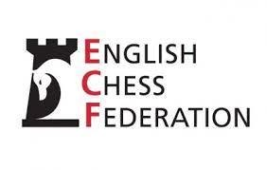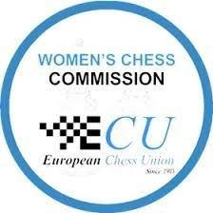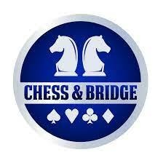

11th Menchik Memorial 2026
WGM / WIM Women’s Norm Event 24-30.08.2026 London
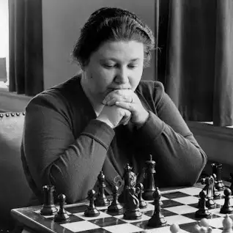
Vera Menchik (1906-44) was the first women's world chess champion, as well as the longest reigning champion, gaining the title at 21 and defending it multiple times until her untimely death.
Although born in Russia to a Czech father and English mother, Vera Menchik lived in England from the age of 15 and became the strongest female player of the era whilst living in Hastings and London.
This year marks 82 years since Menchik was killed when a German V-1 rocket struck her home in Clapham.
Timetable:
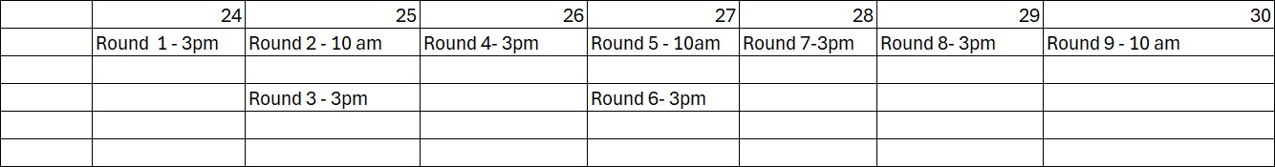
Players:
1 | IM/WGM | Klaudia Kulon | 2395 | Poland
2 | FM/WIM | Lara Schulze | 2345 | Germany
3 | GM/WGM | Keti Arakhamia Grant | 2270 | Scotland
4 | WGM | Elmira Mirzoeva | 2261 | England
5 | WIM | Cecile Haussernot | 2248 | France
6 | WIM | Andreaa Marioara Cosman | 2187 | Romania
7 | WIM | Kasia Dwilewicz | 2152 | Poland
8 | WFM | Kamila Hryshchenko | 2131 | England
9 | WFM | Shambavi Hariharan | 2103 | England
10 | WFM | Anusha Subramanian | 2016 | England
Average rating 2210.
Arbiters:
Chief Arbiter IA Paul McKeown
Deputy Chief Arbiter NA Zoya Boozorginia
Organiser: IA Agnieszka Milewska
Director of Women’s Chess in England

Contact
Aga Milewska
director.womenschess@englishchess.org.uk
X (Twitter): @AgaMilewska123
For further information, please contact Agnieszka at the email address above.

Event Details
Venue
Mercure London Suite Conference Centre, 47 Lillie Road
London SW6 1UD, England
Time control: 90 minutes, plus 30 seconds per move from move 1
Live-streaming platforms: To be confirmed
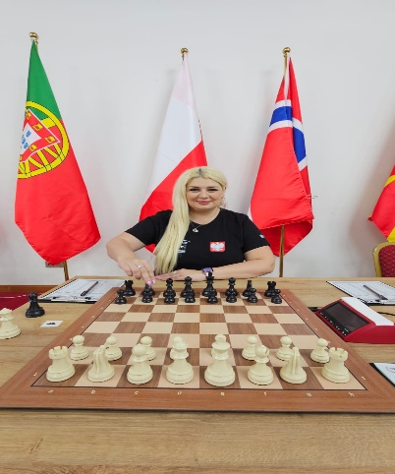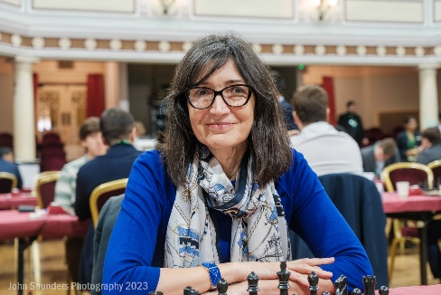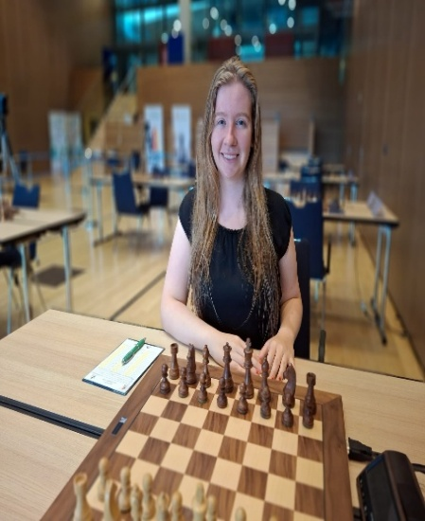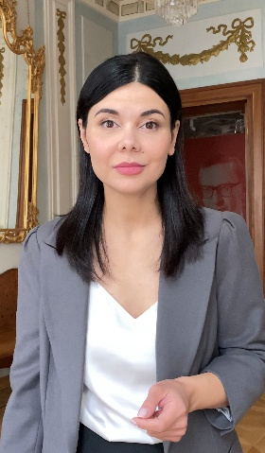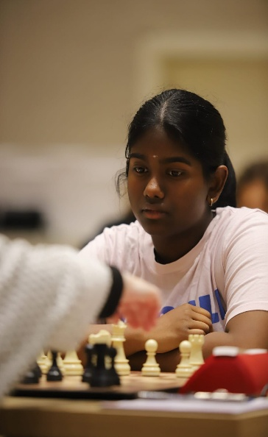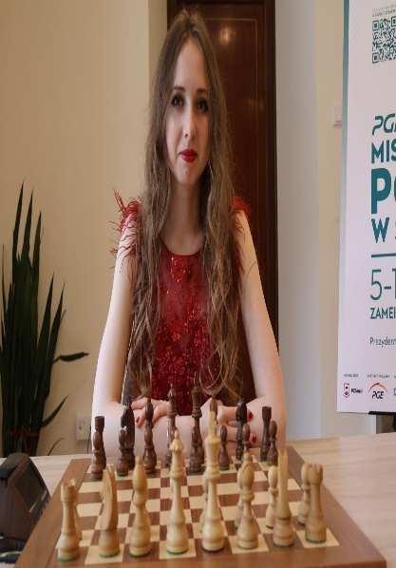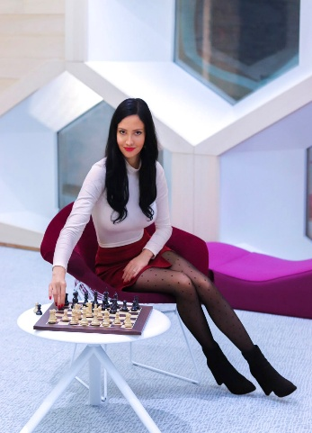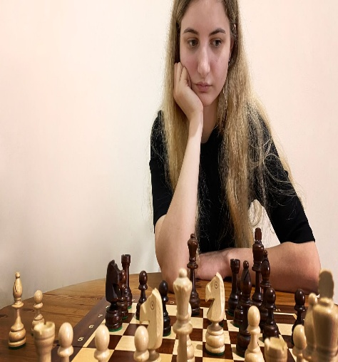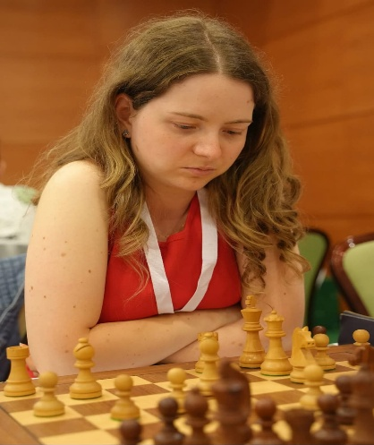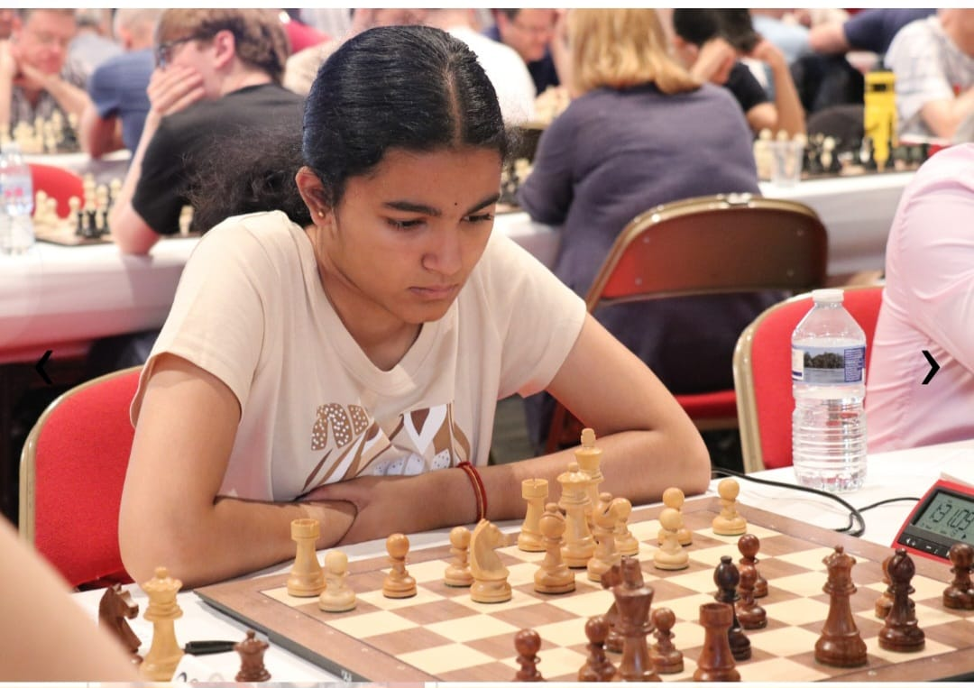

Mind Sports Olympiad (MSO)
Based in London, the Mind Sports Olympiad (MSO) is an international festival and tournament organisation that brings together players from around the world. Its events feature chess, board and card games, abstract strategy games, puzzles, memory disciplines and other tests of mental skill.
MSO began in 1997 at London’s Royal Festival Hall. It now runs an annual programme combining serious competition with opportunities to learn new games, meet international players and join a broad community of mind-sports enthusiasts.

Mission and Community
MSO operates through M S O Limited, a company registered in England and Wales. Through games, it promotes:
- intellectual development and mental fitness;
- strategic thinking;
- international friendship and cultural exchange; and
- mutual understanding.
The event welcomes champions, recreational competitors, junior players, families and newcomers.

Acknowledgement
The English Chess Federation gratefully acknowledges all tournament sponsors and the Chess Trust for supporting this and every previous edition of the event.

