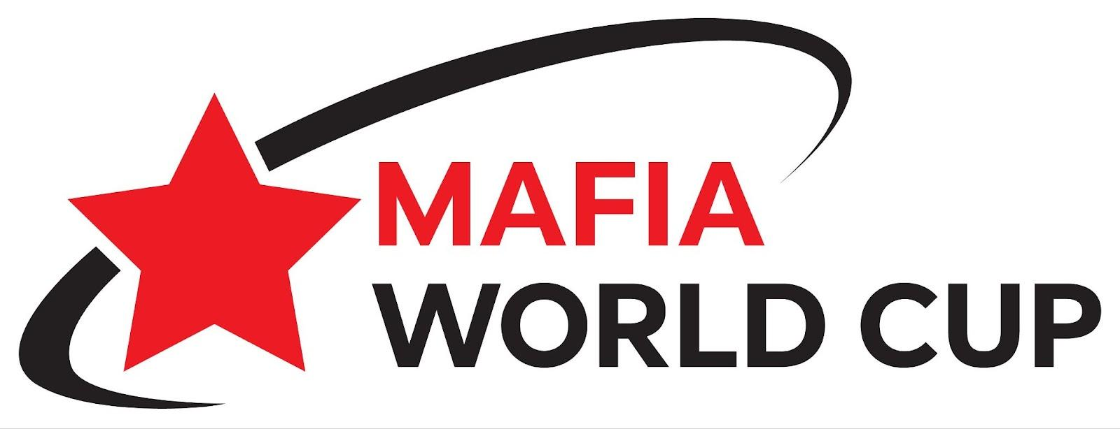

# Tips & Resources (updated on 23 June 2025)

Mafia World Cup Details

Brochures

Rules

Photos

Basic Beginner Videos

Games for Intermediate Players

Masterclass

Websites and Social Media

Mafia Federations

Additional Beginner YouTube videos (NOT in English)

Notable English Mafia Clubs in the English Mafia Federation

NORTH AMERICA REGION

UK & IRELAND REGION

WEST EUROPE REGION

EAST & CENTRAL EUROPE REGION

MIDDLE EAST & ASIA REGION

## 

## Mafia World Cup Details

<https://bit.ly/EML2025>

## Brochures

HOW TO PLAY MAFIA? (edited by the Mafia World Cup and the English Mafia Federation)

<https://bit.ly/HowToPlayMafia>

Edward Aslikyan - Rules & Strategy

<https://drive.google.com/file/d/13KFmyTX3_l2EjGtxUIqxjDVXRrgbpngE/view?usp=sharing>

## Rules

Mafgame Tournament Rules

<https://docs.google.com/document/d/1sJ_uvFAhW0dUA0wLl2p6lw3T0JAYxH7pOmNgc-hUJxY/edit?usp=sharing>

Recommendations of JP MAFGAME of additional points for tournaments

<https://drive.google.com/file/d/1zNcBW20QzdK_45ED86UHCGbACoDIrnIM/view?usp=sharing>

FIIM Tournament Rules

<https://mafiaworldtour.com/fiim-rules>

Emotion Games Rules

<https://docs.google.com/document/d/1dUNt6XZQBMg0bc8rfV5TjtbbywkPq6-m/edit?usp=sharing&ouid=106956478992246384758&rtpof=true&sd=true>

Vancouver Rules - Competitive Mafia Rules and How to Play

<https://docs.google.com/document/d/1ysETmGI20xZWLbevXsWT5D00cs_-mQrQLD6mCB-GjkE/edit?usp=sharing>

## Photos

Photos from games & events <https://www.meetup.com/ukmafia/photos/>

## Basic Beginner Videos

How to Play

<https://youtu.be/Tsgd_yRiBEU>

Extended - How to Play

<https://www.youtube.com/watch?v=LI1t_05WmYU>

What is it & How to Play

<https://www.youtube.com/watch?v=2WNq-SZwnm0>

Animated Tutorial

<https://www.youtube.com/watch?v=HExlcWsuB98&t>

## Games for Intermediate Players

Recent World Cup Games 2025 (Dublin, London, Montreal)

[**https://www.youtube.com/@MafiaWorldCup/streams**](https://www.youtube.com/@WorldMafiaCup/streams)

Game of Masks Day - 1 February 2025

<https://www.youtube.com/live/_Esg40sR_s0?si=1koLwQNGsEFVLkA4>

Game of Masks Day - 2 February 2025

<https://www.youtube.com/live/qE1YeqvRAAM?si=I72TNOUBtCObdpN_>

Krakow Mafia January 2025

<https://www.youtube.com/live/yxfQyz4mmXA?si=y-ZC4MhVBoLXlUcT>

Vancouver Mini-Tournament 2022

<https://www.youtube.com/watch?v=rSY5Vh6F2p4&t>

Vancouver Mini-Tournament 2022

<https://www.youtube.com/live/m-XZwpeL8mQ?si=RuQY54SW14wjC15d>

Vancouver Mafia Club Stream 2022

<https://www.youtube.com/watch?v=wBMhniows2c>

Vancouver Tournament 2020

<https://www.youtube.com/watch?v=e9cbV69qFJ8>

Mafia in English (Zoom) 2020

<https://www.youtube.com/watch?v=9_uVWJVKHqo>

Columbia Cup 2019

<https://www.youtube.com/playlist?list=PLBXmODcbqu4uEw_x2AFNXn7MjalgrVu7V>

## Masterclass

Masterclass with Mika & Fugacity

<https://www.youtube.com/watch?v=0fZeGCEHA5U>

Discussion with Julia (Alegria) from Top-10, Féria Montréal February 2025

<https://www.youtube.com/watch?v=ArBvw7XJG5Y>

Bar (Mentos) analysis of one of games in January 2025

<https://www.youtube.com/watch?v=mMh2SDxmxtc>

## 

## Websites and Social Media

Swipeal

<https://swipeal.com/> (requires an invite, please ask us about getting a referral link)

Ukraine English Mafia Club

<https://englishmafiaclub.com/>

Ukraine English Mafia Club Strategies

<https://englishmafiaclub.com/mafia-strategy.html>

Mafia World Website

<https://the-mafia.net/>

Mafia in English in Valencia - YAML

<https://www.instagram.com/yaml.mafia/>

List of Mafia Federations

<https://mafia.game/federations>

Articles by Maf Club corporation

<https://www.mafportal.com/en/articles/>

English Mafia Events Worldwide (needs to update)

<https://sites.google.com/view/EnglishMafia/>

## Mafia Federations

English Mafia Federation

<https://bit.ly/EML2025>

& <https://www.mafiatournaments.com/>

Mafia World Cup

<https://www.youtube.com/@WorldMafiaCup/streams>

MAFGAME

<https://mafgame.org/tournaments>

Federation of the Intellectual Game Mafia (FIIM)

<https://mafiaworldtour.com/>

Emotion Games

<https://emotion.games/en>

Imafia <https://imafia.org/>

American Mafia League (AML)

<https://americanmafialeague.com/>

MafClub

<https://www.mafportal.com/>

## Additional Beginner YouTube videos (NOT in English)

*Please add **auto caption** translate to English*

How to Play Video

<https://www.youtube.com/watch?v=kwIT-RYaYqw>

Mafia Coordination Gestures

<https://youtu.be/UE7_Axzog0Q?si=gFCbjMqSbS0JOY_c>

Day Time Gestures

<https://youtu.be/FHCBK22nfgA?si=63GQBK3W0LDqozC9>

# 

# **Notable English Mafia Clubs in the English Mafia Federation**

## NORTH AMERICA REGION

**MONTREAL MAFIA CLUB (Mafia Team MTL)**

<https://www.meetup.com/TeamMTL/>

<https://www.facebook.com/groups/mafia.team.mtl/>

<https://www.facebook.com/groups/371439572058705/>

<https://ufmtl.s1.yapla.com/fr/espace-membre/adhesion>

[homeclub.canada@gmail.com](mailto:homeclub.canada@gmail.com)

**VANCOUVER MAFIA CLUB**

<https://www.meetup.com/vancouver-mafia-werewolf-group/>

## UK & IRELAND REGION

**UK MAFIA CLUB (UKMC)**

[ukmafiaclub@gmail.com](mailto:ukmafiaclub@gmail.com)

[www.youtube.com/@UKMafiaClub](http://www.youtube.com/@UKMafiaClub)

[www.meetup.com/ukmafia/](http://www.meetup.com/ukmafia/)

<https://t.me/UK_MAFIA_CLUB>

<https://t.me/UK_MAFIA_CLUB_CHAT>

<https://mafiaworldtour.com/clubs/406/>

<https://mafgame.org/clubs/79/view>

<https://discord.gg/ZuEVgcep>

**RELAXED MAFIA CLUB**

<https://mafgame.org/clubs/101/view>

<https://mafiaworldtour.com/clubs/415>

**BRIGHTON MAFIA CLUB (BMC)**

<https://www.meetup.com/brightonmafiaclub/>

<https://www.youtube.com/@BrightonMafia>

**NORTHOLT MAFIA CLUB**

<https://www.meetup.com/northolt-game-night-meetup-group/>

**WEST LONDON MAFIA CLUB**

<https://mafiainlondon.com>

**EAST LONDON MAFIA CLUB**

<https://www.meetup.com/board-games-social-games-london>

**DUBLIN MAFIA CLUB**

[www.meetup.com/meetup-group-hvqaxwhw/](https://www.meetup.com/meetup-group-hvqaxwhw/)

**CORK MAFIA CLUB**

<https://www.meetup.com/cork-mafia-werewolf-meetup-group/>

## WEST EUROPE REGION

**VALENCIA - YAML MAFIA CLUB**

<https://mafiaworldtour.com/clubs/388>

<https://www.instagram.com/yaml.mafia/>

**ROTTERDAM MAFIA CLUB**

<https://t.me/sergiiukr>

<https://www.instagram.com/rotterdam_mafia_club/>

<https://www.youtube.com/channel/UCR9QJBTx3JmvvCO3qFgpCNA>

<https://mafiaworldtour.com/clubs/368>

**AMSTERDAM MAFIA CLUB**

<https://mafgame.org/tournaments/484/view>

**ZURICH MAFIA**

## EAST & CENTRAL EUROPE REGION

**MAFIA CLUB “CHAMPIONS LEAGUE” PRAGUE**

<https://mafiaworldtour.com/clubs/317>

<https://mafgame.org/clubs/4/view>

<https://www.instagram.com/mafia_clp/>

**KRAKOV MAFIA CLUB**

<https://www.instagram.com/white_mafia_club_in_english/?igsh=MWZ5c21iOXgwdzlmaw%3D%3D>

## MIDDLE EAST & ASIA REGION

**ENGLISH MAFIA LEAGUE TEL AVIV**

<https://mafgame.org/tournaments/401/view>

<https://www.youtube.com/live/i34RqWrO5-Y>

**NIGHTFALL**

<https://mafiaworldtour.com/clubs/374>

<https://www.facebook.com/MafiaclubNightfall/>



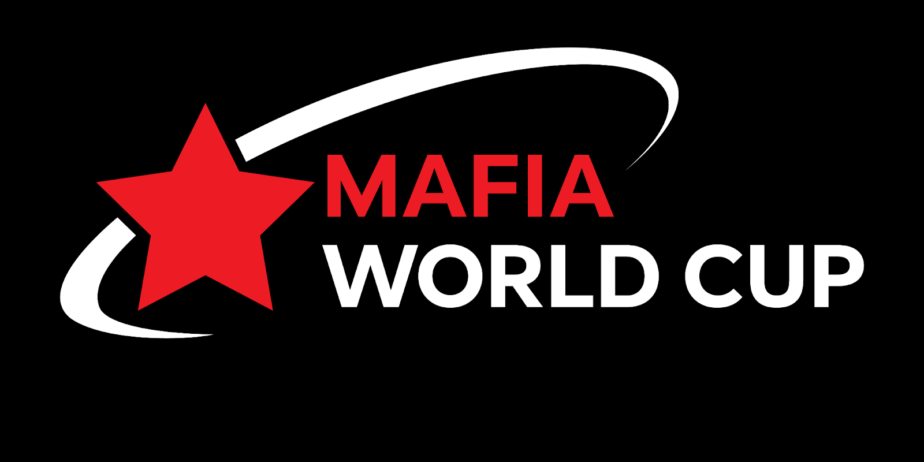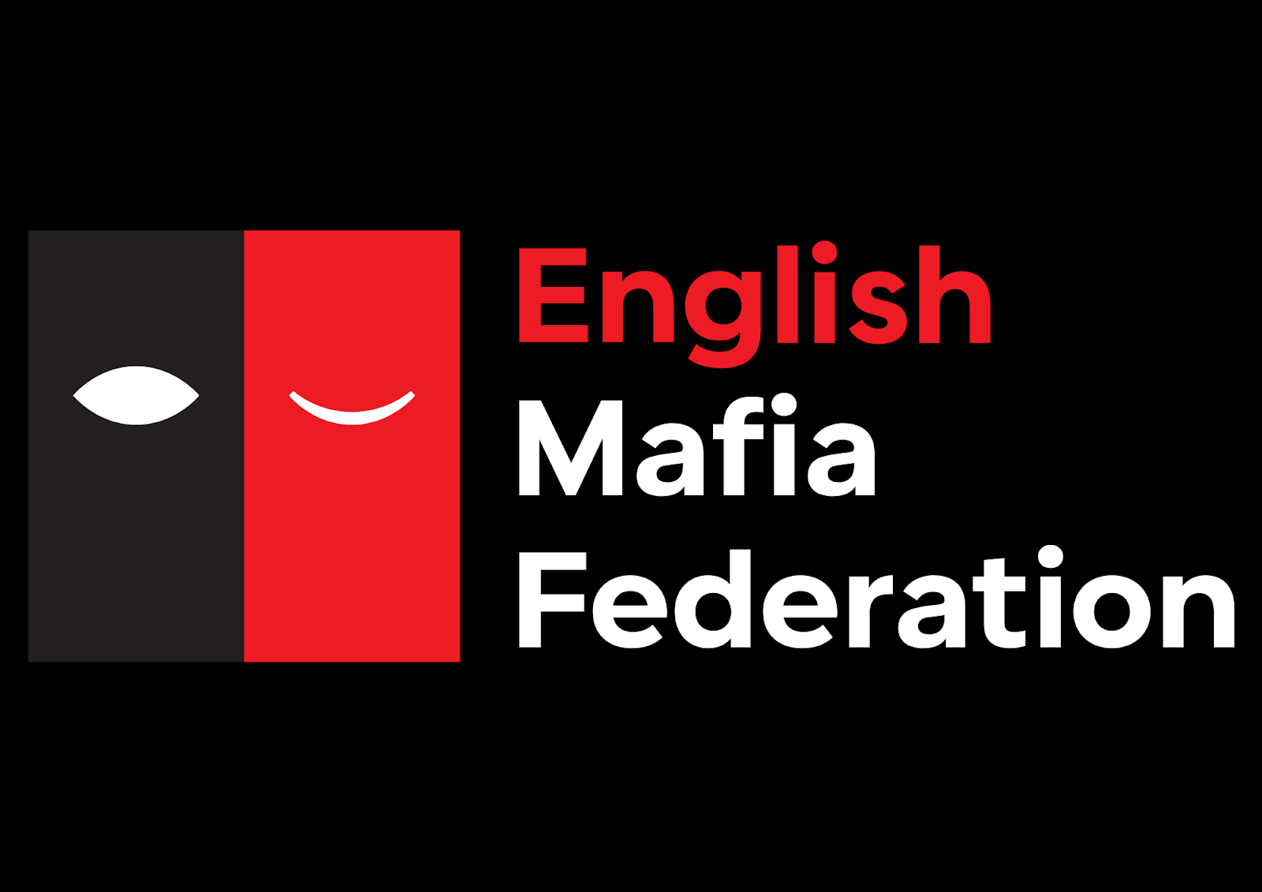

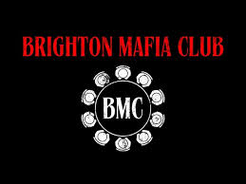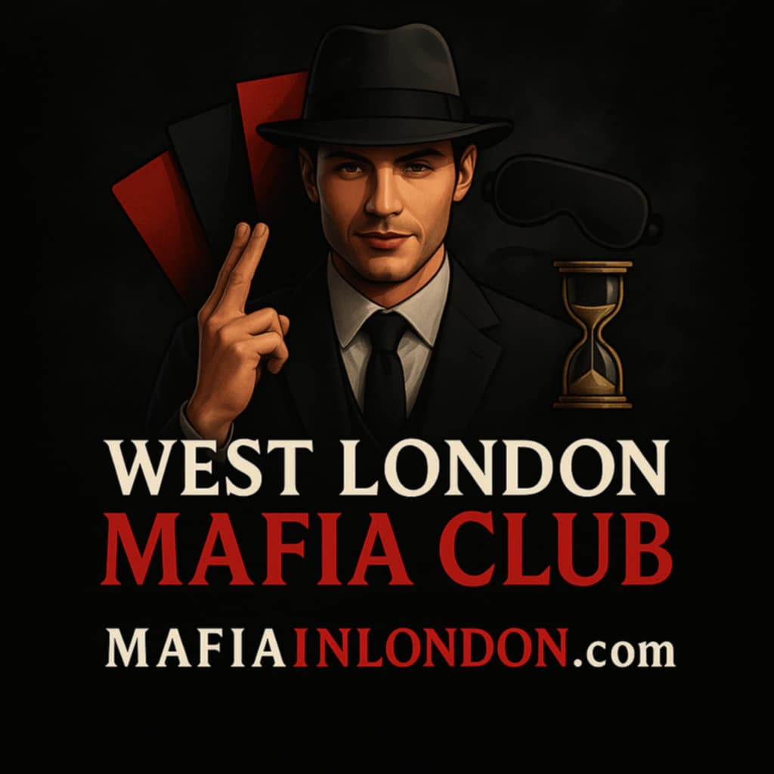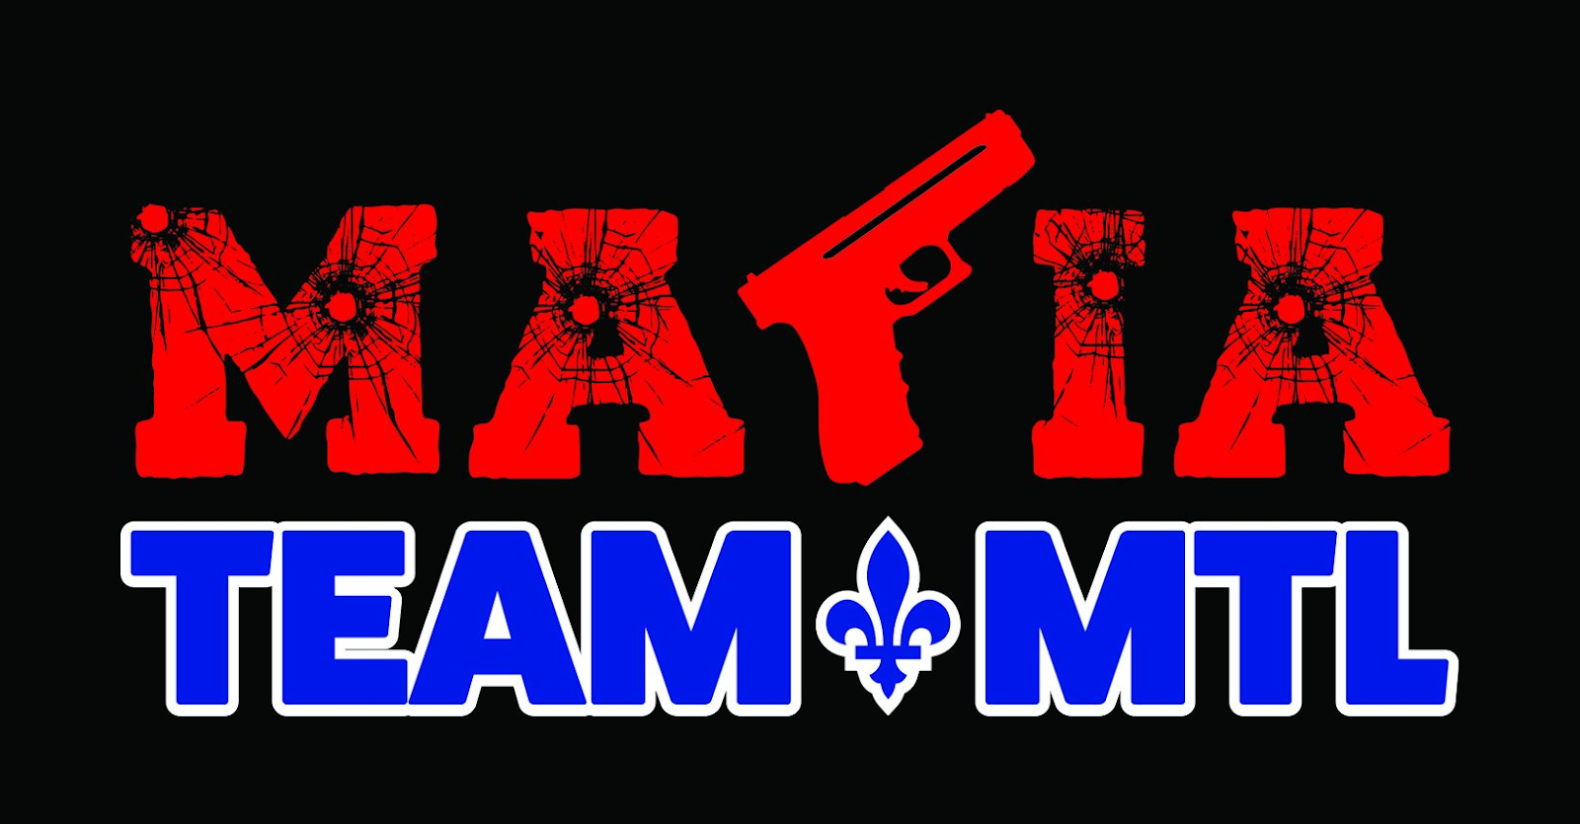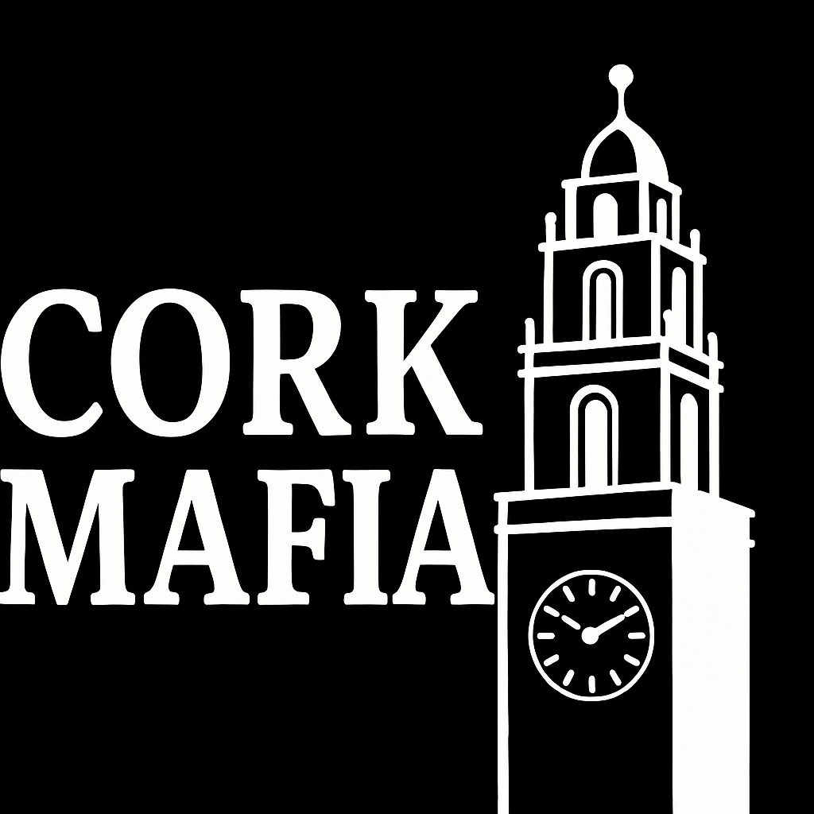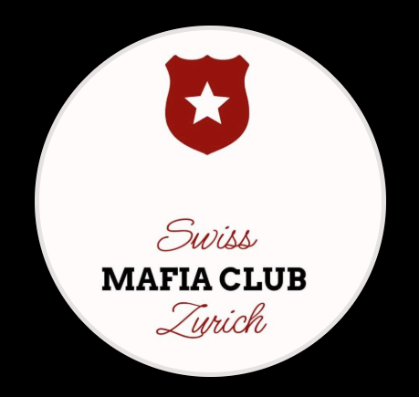

**SEND US YOUR LOGO!**